Changing How You Teach: A Skills Based Learning Approach in Secondary Education
By: Whitney Major - Southwest Director ASTA
Lakeside High School, Hot Springs, AR

“Critical thinking skills are extremely important. If you can think critically about a problem we have to solve on the job, work independently, and seek out the correct answer, then I will hire you today. The content you need to be successful, I can teach you while on the job.” Words spoken by a panelist at the STEM Conference on April 14, 2023 to young women across the state.

Powerful words that speak truth into what employers are looking for in future employees. The main goal of high school is to prepare students to become active members of society and the workforce in our communities. By using a skill-based learning approach in the classroom, we, as educators, can make the content learned in Chemistry class or 11th grade English more applicable to the students’ future employability.

Most secondary classrooms focus on the core content, while using the skill to help reinforce the learning. We then test students against the learning of the specific content, which causes confusion when students are learning the information. It should not just be about the content, but instead how the content enforces the skills needed to be successful in a science classroom or future career.

Critical thinking, problem solving, communication, team work, drive….the list goes on and on as to what skills employers are looking for in the future workforce. However, how often do we focus our lesson planning, activities, and assessment around the content specific to our course in secondary education. The answer is “far too often.” Letting go of our current practices to test the idea of skills based learning in the classroom requires teachers to focus on assessing the skill, while using the content to help students practice the skill using applicable material, scenarios, or environments. This not only allows educators to teach students how to achieve the correct answer in the practice that we use (i.e. modeling atoms in chemistry), but it also helps students to achieve the correct answer in every instance they see the same skill (i.e. modeling). They essentially look for the pattern and find a way to replicate the problem solving methods.

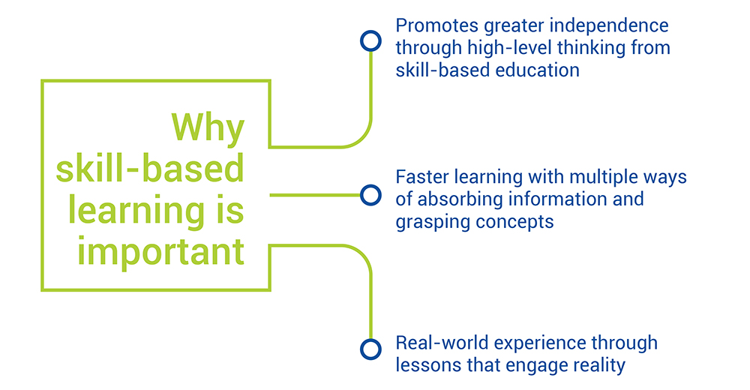
Using skills based learning, students have the potential to gain a deeper understanding of the skills needed to be successful when working through a problem, like using critical thinking skills to analyze a set of data. Skills-based learning allows students to replicate this process later in their lives, when they will be studying in college, preparing for an industrial entrance exam, or completing a certification exam. Most secondary educators today use knowledge based learning to drive instruction by building on a concept learned from the lesson previous to help students reach the learning level for future lessons. However, by using skills-based learning educators can transform students into independent thinkers and prepare them for challenges they may face in the future.

For more information about skills based learning: https://www.edvantic.com/blog/knowledge-vs-skills-what-education-must-provide

